**Santa Rosa Neptunes Swim Club**

**9. Dolphin Timing System Quick Guide**

10/21/2017

Contents

Equipment 1

Setup 2

Timing Equipment Operator Duties 4

Intermediary Duties 6

Reconfigure a spare timer for lane and seat 8

Troubleshooting 8

Dolphin Timing Equipment Operator Checklist 11

Dolphin Intermediary Checklist 13

# Equipment

* Laptop with 3 USB and LAN ports, power supply, Dolphin software and 1-button hot key print screen software installed
* USB printer, USB cable and power cord, paper and spare toner cartridges
* Power strip
* 2 power extension cords – one for laptop and printer, one for scoreboard
* Wireless mouse with USB adapter
* Dolphin Base Unit with USB interface
* Dolphin Starter Unit with mini-BNC output
* Dolphin Mini-BNC to BNC Cable
* BNC to dual banana adapter
* Dolphin Wireless Scoreboard Adapter
* Scoreboard with power cable
* 150’ LAN cable
* 24 Dolphin Wireless Stopwatches, 3 per lane labeled 1A, 1B, 1C, 2A, 2B, 2C, etc.
* 25 Spare 9V batteries
* Small flat blade screwdriver

# Setup

Before meet starts:

1. Connect laptop and printer to AC power and turn on.
2. Connect printer, mouse and Dolphin Base Unit to laptop USB ports and turn on mouse.
3. Hang Dolphin Starter Unit from starting system and connect them together with the Dolphin Mini-BNC to BNC Cable and BNC to dual banana adapter.
4. Connect Dolphin Wireless Scoreboard Adapter to scoreboard, connect scoreboard to power, and turn scoreboard on.
5. Connect the laptop to the computer room via LAN through the computer room LAN switch with the 150’ LAN cable.
6. Turn on all Dolphin Wireless Stopwatches being used -- 3 per lane, 8 lanes or 24 transmitters max -- by pressing the reset button for 5 seconds.
7. Launch Devices and Printers, right click on connected printer and select Set as Default Printer. Select OK if window pops up saying “Setting this printer as default will stop managing your default printer.”

Before each session starts:

1. Launch Dolphin software from the icon on the task tray. Verify you see the starter transmitter and all of the lane timer transmitters, and that none have low battery red icons.
2. If the starter transmitter or any of the lane transmitters have a low battery, use the screwdriver to replace it with spare 9V battery.
3. Click Logging Enabled. This will write the results to file and automatically advance the heat.
4. Turn on scoreboard:

* Click Enable Scoreboard
* Scoreboard lines = 1
* Set number of lanes to match pool, i.e. 6, 7 or 8
* Set scroll time per referee preference, typically 1.5 or 2 seconds
* List by place then lane
* Click OK
* Make sure scoreboard is on.

1. Test starter:

* Ask the referee to announce and perform a test start.
* Verify clock starts running.

1. Test Dolphin Wireless Stopwatches:

* Press a black button on each stopwatch once.
* Verify all stopwatch times were recorded.

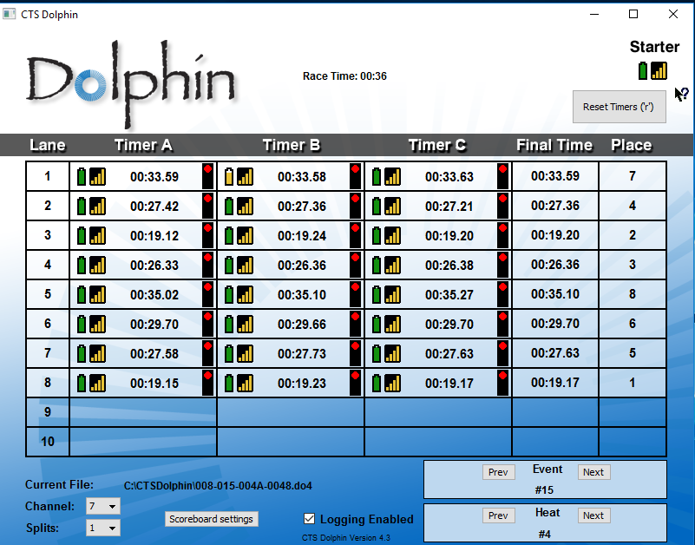

1. Test screen capture print:

* Press Ctrl and PrnSc. This should bring up Gadwin Printscreen capture box.
* If the box is not aligned with the Dolphin window, drag and drop the box edges to match.
* Press Enter to save box alignment changes.
* Press Enter to print. Verify screen capture of window only is printed portrait.

# Timing Equipment Operator Duties

Overview

This person operates the laptop. Their primary tasks are to capture times, save them both electronically and on paper, and record the file number associated with each heat and any changes in lane assignments. Since it is easy to lose time data and the outcome can be undesirable, this person needs to do the following:

* Either be already trained, or be trained on the job by an experienced operator.
* Focus on collecting and recording data, not partaking in distracting activities such as having deep conversations with other people, or using a cell phone.
* Keep track of which event and heat is in the water, and keep the Dolphin software heat and lane configuration updated accordingly.
* Keep track of the last athlete swimming in a race, not saving the data before that last swimmer is in.
* Print the screen and save the data quickly after a race to prepare for the next race to keep the meet on schedule, but…
* Communicate clearly to the starting referee if there are problems, telling them firmly that they need to wait.

Procedure

At the beginning of each event:

1. Write down the event start time on the timeline for referee reference.
2. Write down the event start time in the upper right corner of the Colorado page.

During each heat:

1. Write the file number in the left margin of the event program sheet stamped “Colorado”. *This is so the computer operators know which file to import results from.*
2. Set the heat and lane information in the Dolphin software, making sure it matches what the Colorado sheet says. The heat automatically advances in the software since data file logging is enabled, but if it’s a new event, or if the boys and girls heats are being run alternated across two events, you will need to edit both event and heat.
3. Cross out no-shows on the event program sheet with a pencil, and write DNS on the side.
4. Edit lane assignments as instructed by the referee with a pencil.
5. If a swimmer does not finish the race, write DNF next to their name with a pencil.

Add picture(s) of marked up Colorado sheet – DNS, move swimmer, DNF, file names, event start time

After each heat:

1. Make sure all swimmers have completed the race. *Note: failure to do so can result in losing the time for that swimmer.*
2. Click on Dolphin window to select it, if it is not already selected.
3. Press Left Ctrl-PrintScr. This launches Gadwin Printscreen and shows a box where the capture window is.
4. If the capture window box does not line up with the Dolphin window, drag and drop the handles along the edges of the box until they do. *This should only have to be done once, unless someone moves the Dolphin window.*
5. Press Enter. Verify the printer prints the capture box.
6. Click “Reset Timers”.
7. Click “Yes” to confirm. *This saves the data to the file that the computer operators will import.*

After each event:

1. Give the meet program stamped “Colorado” to the Chief Timing Officer.
2. Edit event in the Dolphin software to increment to next event.

After each session:

1. Wait until the results files are uploaded to the computer room.
2. Turn off computer, even if there is a session the next day. *This is done to make sure software doesn’t get in a stale state due to a memory leak.*

# Intermediary Duties

Overview

This person handles the paperwork. Their primary task is to receive and organize all paperwork associated with an event, check results for accuracy, and submit to the administrator.

Procedure

After each heat:

1. Remove heat screen shot printout from the printer and verify the event and heat are correct. If they are not, write the correct heat and event information in pencil on the printout.
2. Check each lane for 3 watch times. If there is a missing time, circle the blank time in pencil to flag this discrepancy to the admin per the example below.

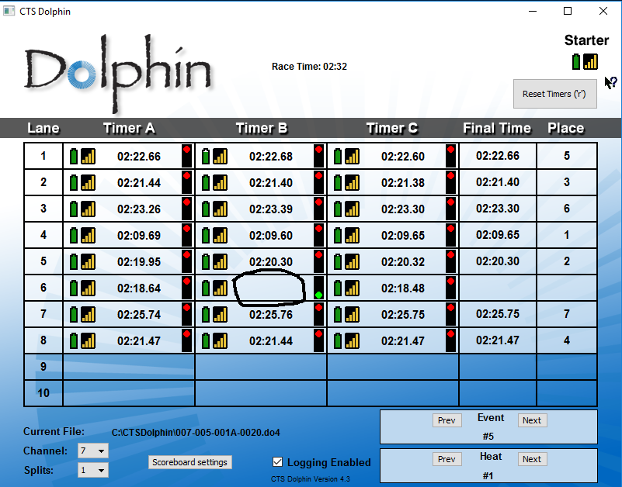

1. Check each lane for a span of times of less than 0.3 seconds. If there is more than 0.3 second span, circle the 3 numbers in pencil to flag this discrepancy to the admin.

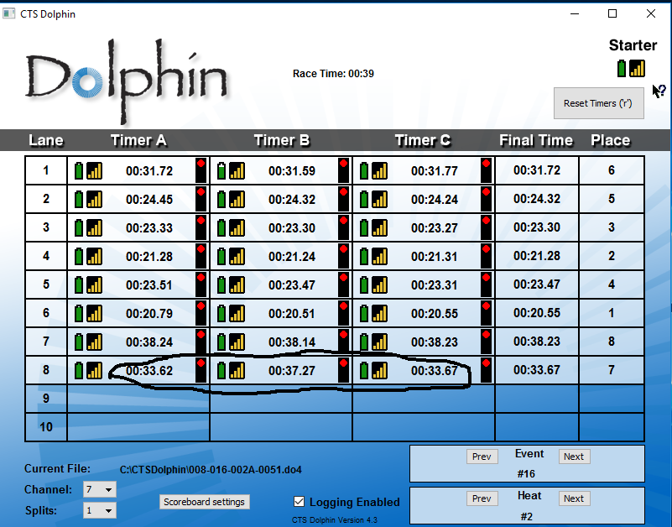

1. If no lanes have a discrepancy, put a check mark in the right margin to indicate that you have looked at it.
2. Circle event and heat so it is easy to find.

After each event:

1. Collect the meet program stamped “Colorado” from the Timing Equipment Operator.
2. Collect the 2 to 3 meet programs stamped “Referee” and any DQ slips from the referees.
3. Staple DQ slips to respective green DQ cards.
4. Collect the 8 lane timer sheets from the lane timers via the Runner. Make sure the event is correct and put them in numerical order.
5. Create an event packet with the paperwork clothes-pinned together in the following order:
   1. DQ slips
   2. “Colorado” meet program
   3. “Referee” meet programs
   4. Heat screen shots from Dolphin system, in heat order
   5. Lane timer sheets, in lane order
6. Give event packet to Admin.

# Reconfigure a spare timer for lane and seat

If a watch stops working, configure spare watch to match the correct lane and seat:

* Press Reset and Stop buttons simultaneously for a few seconds
* Press Reset to advance to next screen
* Press Stop button to change displayed information
  + Verify channel is correct, matching other working watches i.e. “7”
  + Set lane to desired lane, i.e. “4”
  + Set seat to desired seat i.e. “C”

# Troubleshooting

* If the scoreboard stops updating, power cycle the wireless scoreboard receiver.
* If the printer stops printing, power cycle it. If it still doesn’t print, try a different USB port.
* If the scoreboard gets started before the referee starts it, don’t worry, one of the lane timers accidentally hit their button which started it, but the referee starter signal will re-start it. *The author sees this as a shortcoming of the system to not be able to disable starting from the lane timers.*
* If the Dolphin software stops writing files, power cycle and try again. If it persists, swap computers and use one of the computer room computers for the Dolphin and vice versa – they are configured to be interchangeable. Then after the meet take the Dolphin computer and uninstall the software, make a backup of the data files in C:\CTSDolphin, then delete the C:\CTSDolphin folder, then reinstall the software. *Something in the software seemed to get corrupted when this happened.*
* If you need to reprint a screen shot, you can find the screen shots saved in the My Computer \Pictures\My Screen Shots\ folder. You can browse them until you find the file based on date and time and checking for the correct event and heat in the screen capture.
* If the Dolphin program starts acting erratically -- such as resetting without the timing equipment operator initiating a reset, or not responding to the starter -- reboot the computer and relaunch Dolphin and set up logging and the scoreboard. *This could be caused by not turning off the Dolphin software or computer overnight and the software could have a memory leak that causes problems after several hours, resulting in unexpected behavior.*
* Raise base up high to get better reception from watches further away.
* Type on keyboard slowly to not outrun the software lag.
* Check battery levels at first boot of watches for best accuracy. Replace if half full.

This page intentionally left blank so the following page can be removed and put in a clear shield and used as a quick reference during the meet.

# Dolphin Timing Equipment Operator Checklist

During each heat:

1. Verify event number and heat number are correct.
2. Write file number on left margin of Colorado meet program sheet.

After each heat:

1. When all swimmers are finished, press Left Ctrl-PrntScrn. Verify Gadwin Printscreen box is around Dolphin window.
2. Press Enter to print screen and save to file.
3. Type “r” for Reset.
4. Type “y” to confirm.

After each event:

1. Give Colorado program sheet to intermediary.

This page intentionally left blank so the following page can be removed and put in a clear shield and used as a quick reference during the meet.

# Dolphin Intermediary Checklist

After each heat:

1. Collect Dolphin printout heat printout from printer.
2. Circle heat and event.
3. Circle any missing watch times.
4. Check all watch times across a lane to make sure they do not vary more than 0.3 seconds. If they do, circle the lane row.

After each event:

1. Create a packet of event papers held by a clothespin with the papers in the following order:
   1. DQ slips from Chief Stroke and Turn Judge.
   2. Dolphin meet program from timing equipment operator.
   3. Referee meet program(s).
   4. Dolphin heat result printouts.
   5. Lane timer sheets delivered by runner.
2. Give event packet to admin or meet referee for review before sending it to the computer room.