QUICK START GUIDE
U-BMS CANBUS WITH VALENCE CYCLER
VERSION 0.1
August 23, 2006

REVISION TABLE

Revision | Changes | Reason | Date | Author
0.1 | Initial revision to support Valence Cycler version 2.0.1 | Starting Point | August 23, 2006 | Dale Barnard

TABLE OF CONTENTS
REVISION TABLE 2
TABLE OF CONTENTS 3
INTRODUCTION 4
WALK-THROUGH 4
SUPPORT 10

INTRODUCTION

This quick-start guide aims to get a user started with the Valence Cycler application when interfacing with a Valence U-BMS with the CAN Bus interface kit. It should require five or ten minutes to get started monitoring a U-BMS connected to one or more U-Charge XP modules. This guide assumes that you have already properly connected your computer to the U-BMS using the Valence CAN Bus U-BMS interface kit.

WALK-THROUGH

1. Install the Valence Cycler into the default location under Program Files by double-clicking on the Setup.exe file and following the directions.
2. The installation will place a Valence Cycler icon on your Windows desk-top and also in the Start Menu. Launch the application by double-clicking one of these icons.
3. If you have never run the Valence Cycler before, you will be greeted with the Welcome Dialog:
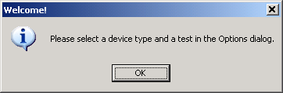

4. After dismissing the Welcome Dialog, you will see the fairly empty main window:
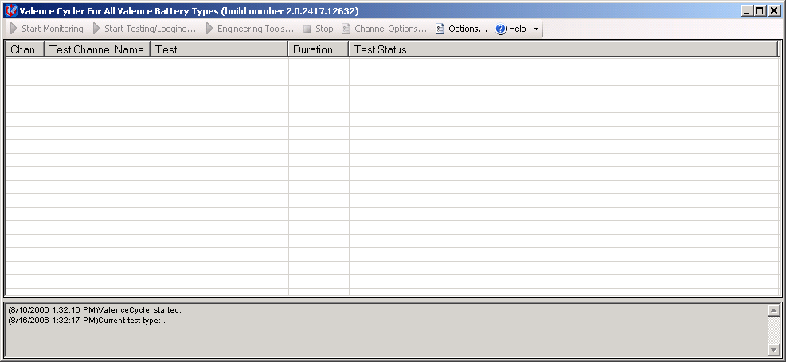

5. Open the Options Dialog by clicking Options on the toolbar. It will appear as shown below:
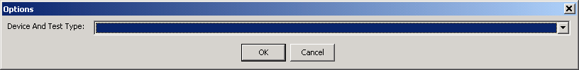

6. Select “U-BMS Monitoring/Logging” from the drop-down box. The Options Dialog will then change:
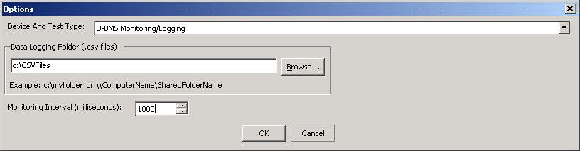

7. Choose a Data Logging Folder that will contain the comma-delimited files containing logged U-BMS data. These files should be on a hard drive with plenty of free disk space, perhaps a minimum of 20 GB, because of the large amount of data collected from a U-BMS.

You can adjust the Monitoring Interval to the number of milliseconds you wish to pause between log entries. For example, if you are logging U-BMS data for several hours, you may wish to write a log entry every 10 seconds, so enter 10000. If you wish to collect more frequent data, you could enter 500. If you enter an interval smaller than the processing time required for one interval, such as 1 ms, the Valence Cycler will simply collect data as fast as it can. For starters, you may wish to use 500 ms or 1000 ms.

8. When you press OK in the Options dialog, the main window will appear again, but this time, it will be populated with many more controls:
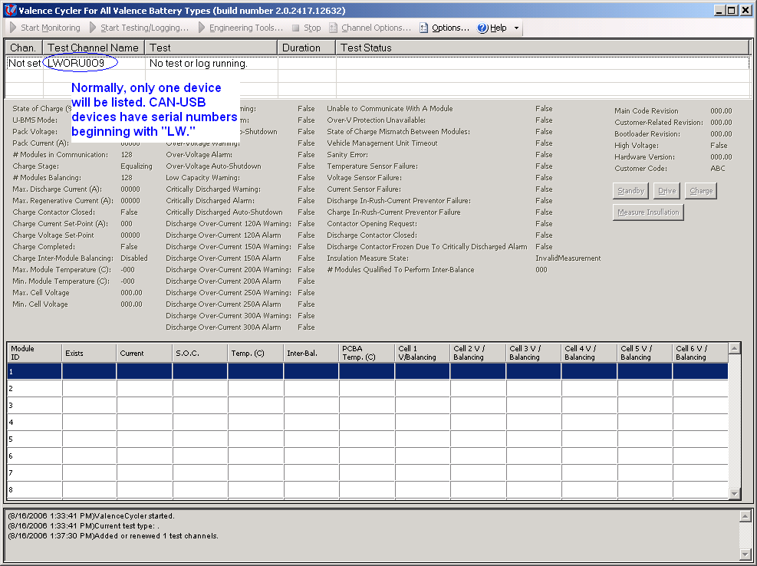
The Valence Cycler is designed to operate with more than one test channel at a time. A single test channel can connect to a single U-BMS. Most users will be using only one CANUSB device, and will thus see only one test channel, as shown above. The controls will appear grayed out. If you see more than one test channel, select the one that begins with the letters “LW”, which stand for Lawicel, the manufacturer of the CANUSB devices. The test channel name is the serial number stored in the CANUSB device.

9. Once you have selected a test channel, click Start Monitoring on the toolbar. After a pause, you will see data being collected from the U-BMS:
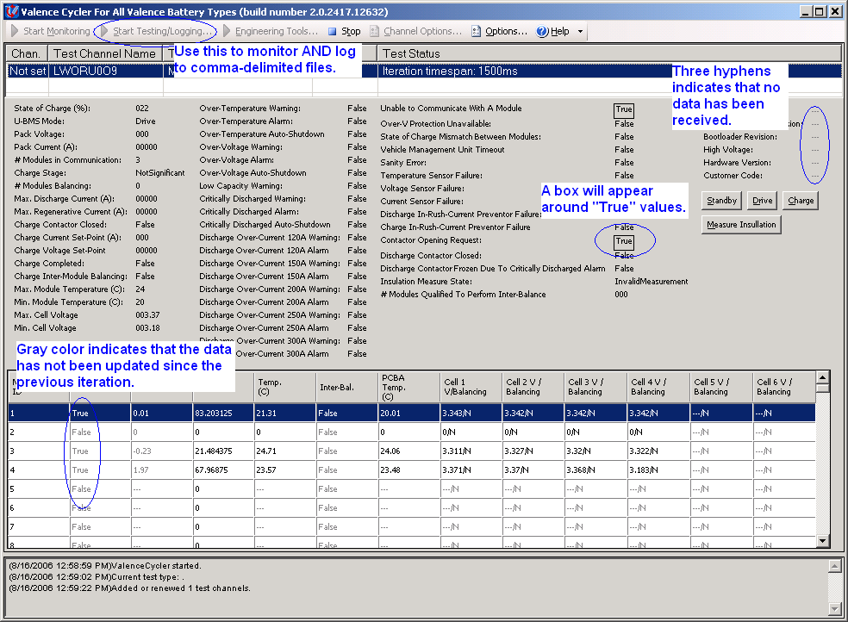

10. Once you have successfully viewed data from the U-BMS, you can try logging data to files. Press Stop on the toolbar to stop monitoring. Now press Start Testing/Logging, which will show the following dialog:
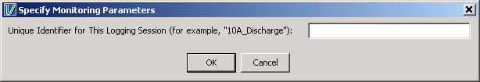
Type in a unique identifier for your logging session. For example, you could type in “discharging at 2A” or “testing self-discharge”. This information will be used as part of the folder name that will contain your log files. For example, the auto-generated folder name may be “2006-08-17_15.23.48.153_Monitoring_or_Logging_discharging_at_2A”. Note: The folder name includes, “Monitoring_or_Logging”, but in this case, it is doing both: Monitoring the U-BMS values on the main window and logging them to a file.

11. After pressing OK to dismiss the Monitoring Parameters dialog, the application will begin logging data, continuing until you press the Stop button on the toolbar.

12. After stopping the log, you can view your log files in the folder that you specified in the Options dialog. For example, in the folder
C:\CSVFiles\ 2006-08-17_15.23.48.153_Monitoring_or_Logging_discharging_at_2A, you may see files as shown below:

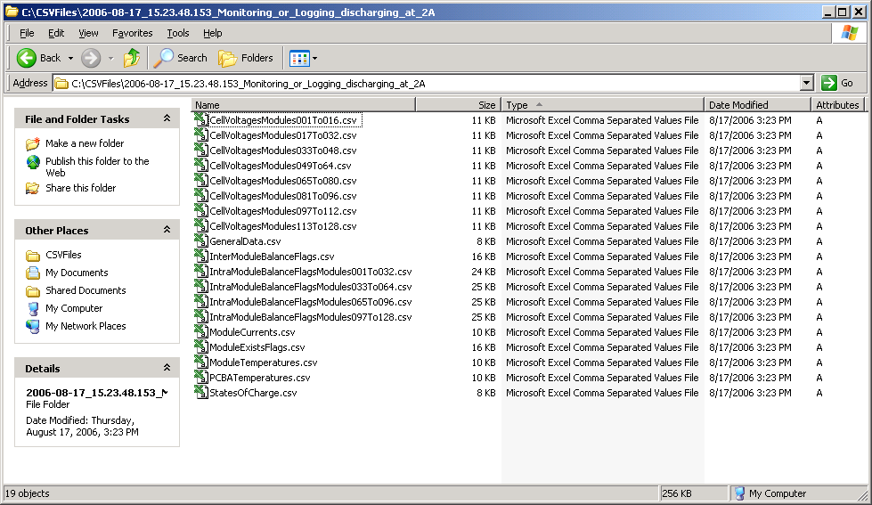

Typical users may use Microsoft Excel to view the CSV files, but any text editor or spreadsheet program will work. Excel limits the number of columns in a CSV file to 256. The Valence Cycler collects too many different types of data to log it all to a single file that can be opened by Excel, so it splits it into 19 different files based on the type of data. In each file, you will find entries for the same timestamp because for each iteration, the application logs an entry to all of the files.

13. If you have Excel, open the first file. It will appear as shown below:
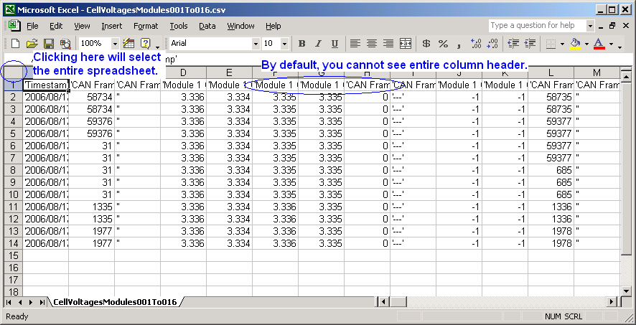
By default, it is difficult to see the column names. Each version of Excel has a way to auto-format the spreadsheet. If you are using Excel 2003, you can select the entire spreadsheet by clicking on the top-left corner of it, then selecting the Format menu, then Column, then Autofit Selection. It will expand the columns to show the headers:
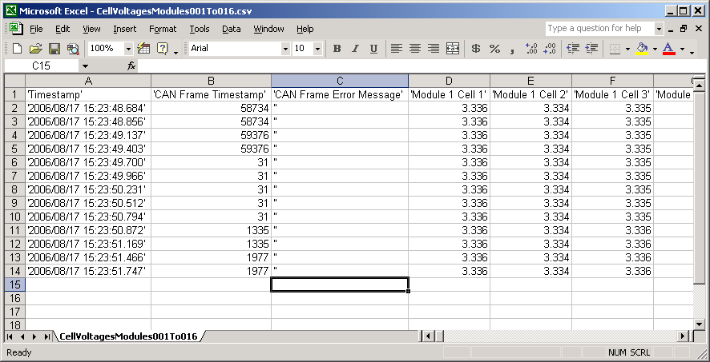

14. To understand the spreadsheet data, you must understand how CAN Bus works. The data from the U-BMS is divided up into CAN frames, each of which includes its own timestamp. Each CAN frame that is sent to the Valence Cycler has a different timestamp. It is important to realize that this timestamp is NOT the same timestamp as the first column of the spreadsheet. The CAN frame timestamp “rolls over” every 60 seconds, and is thus only useful when compared with previous timestamps. For example, in the data shown above, the first two rows start with a CAN frame that has timestamp 58734 milliseconds. However, in the first column, you will note that the two iterations have different timestamps. This means that in the time between the iterations as you defined in the Options dialog, no new CAN frame was processed for that particular piece of data.

If you scroll horizontally through the Excel file, you will see more CAN frames with different time stamps. The CAN frame timestamp applies to the columns to the right up until the next CAN frame. This CAN frame data is included for completeness, but is typically only useful for determining how fresh the data is from the U-BMS.

SUPPORT

Please send bug reports or feature suggestions to your Valence representative. We appreciate your feedback.

